**CP Club 365 Days Challenge**

**Programming language – C++**

**Problem Statement**

<https://www.interviewbit.com/problems/best-time-to-buy-and-sell-stocks-ii/>

Git :- <https://github.com/Vedantbharad2603/CP_club_365_Days>

**Your Code**:

// 0x101Day of 0x365Days challenge

// VEDANT BHARAD

// 26-1-2023

#include <bits/stdc++.h>

using namespace std;

int Solution::maxProfit(const vector<int> &A) {

    if(A.size()==0)

    {

        return 0;

    }

    int sum = 0;

    for(int loop=0;loop<A.size()-1;loop++)

    {

        if(A[loop+1] > A[loop])

        {

            sum += A[loop+1]-A[loop];

        }

    }

    return sum;

}

int main()

{

    vector<int> v;

    int arr[] = {1, 2, 3};

    int N = sizeof(arr) / sizeof(arr[0]);

    for (int i = 0; i < N; i++)

        v.push_back(arr[i]);

    cout<<maxProfit(v);

    return 0;

}

**Output (Screen Shot)**:

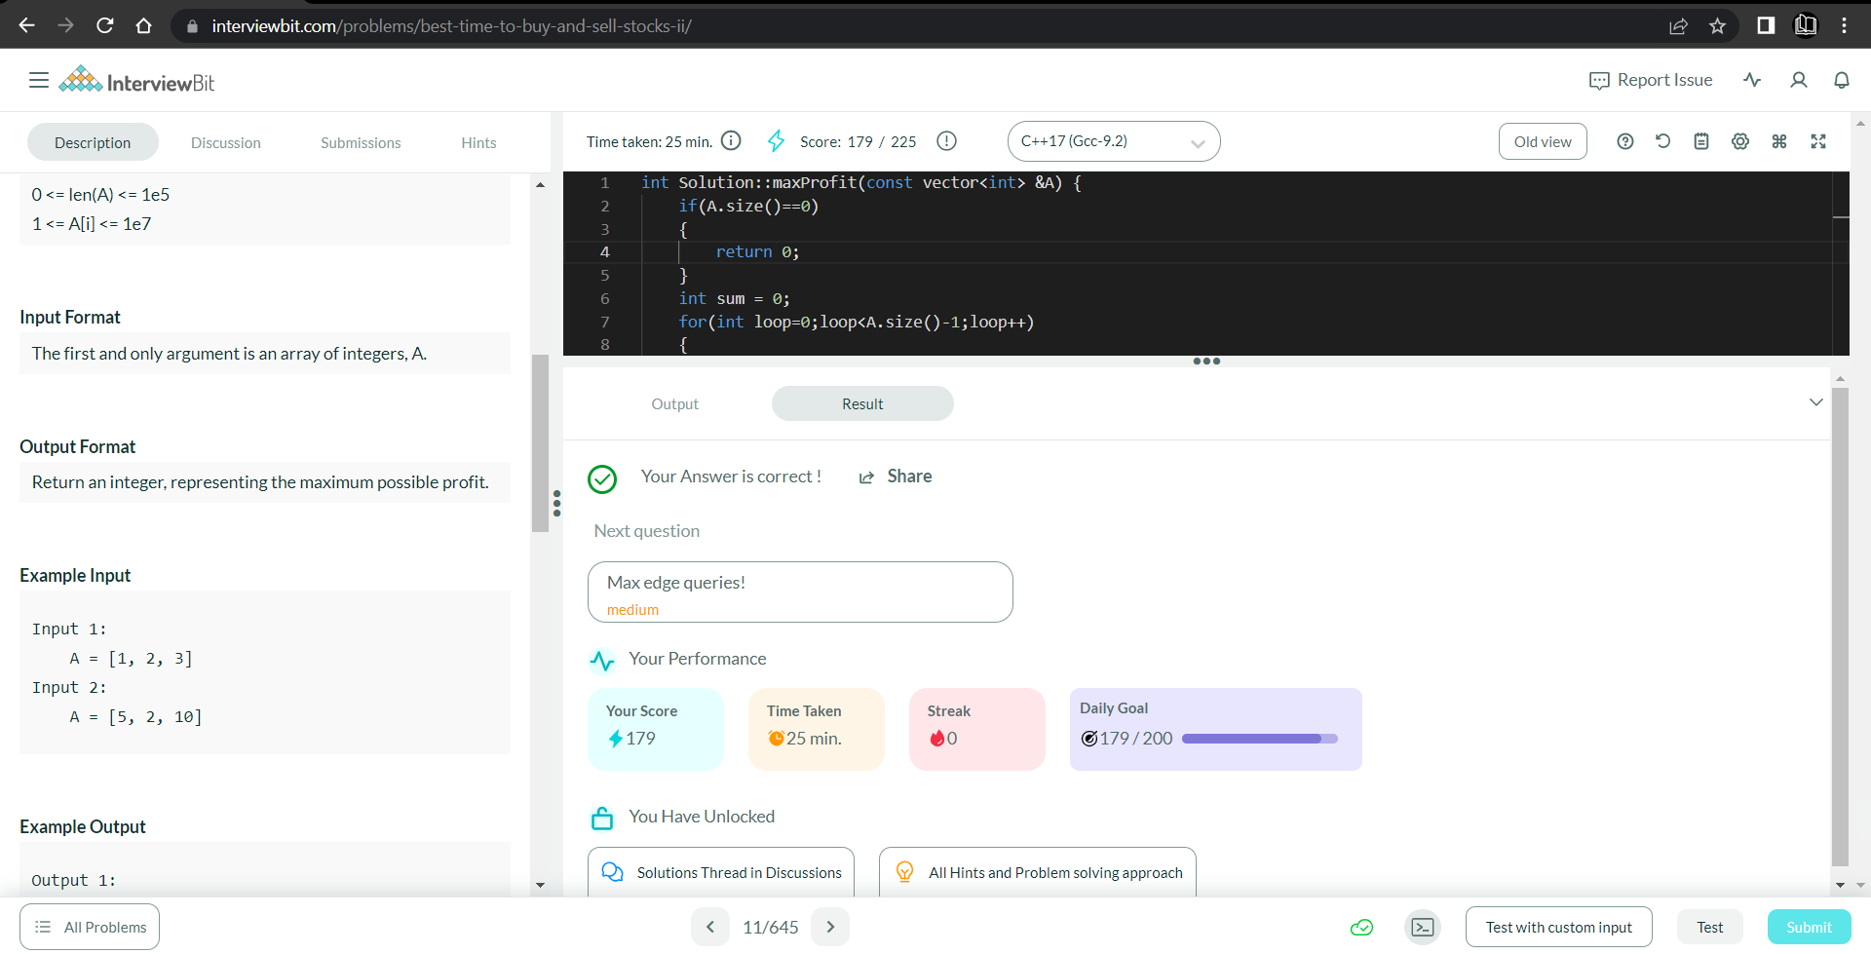

**Understanding about problem:**

* In this task I need to return one int number which is max Profit from given array of Stocks price.

Note: If you can't understand the problem, feel free to contact us and we'll help you. Please don't copy and paste from anywhere.

ALL THE BEST

Team CP Club